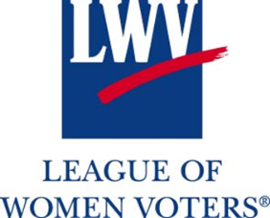 | Increasing League Impact  The Membership and Leadership Development Model
Spring 2015
Get Involved in Your State:  [Add State MLD Rep Info Here]  [Add state MLD resources Here]  State Coach Spotlight  [Use this space to highlight the successes of a state coach. Include a picture if possible.]  Tools You Can Find at forum.lwv.org:  YPTF Toolkit: Building the League of Tomorrow  Tools, tips and ideas for engaging with young volunteers and leaders.  Membership Forum Group  A discussion group dedicated to membership and filled with ideas for making events engaging and attractive to potential members. Also where you can find the MLD Handbook.  LWVUS Webinar Library  Find recorded webinars on topics ranging from “Voter Registration Training” to “Storytelling for Recruitment” and everything in between!  How to Create a League Facebook Page  Step by step instructions on creating an engaging Facebook page to kick start your League’s social media presence.  Do You Know Your LWVUS Board Liaison?:  Board / State Liaison Assignments and Contact Information  For More MLD Info from LWVUS:  Contact Shauneen Grout at sgrout@lwv.org | What is the MLD?  The Membership and Leadership Development (MLD) Program aims to help local Leagues intentionally focus on strengthening and growing the League and the League's impact, with the help of state and national coaches for support. Currently, over 170 state coaches are working with 25 national coaches (also known as the Ruth S. Shur Fellows) to provide guidance, mentoring, and support to local Leagues in tried-and-true techniques proven to recruit new members and engage and retain current members, develop leaders and examine sustainability. As we look towards the League’s 100th birthday in 2020 we hope to continue leveraging new this new capacity, created by the MLD to create more impact in our communities, for our democracy.  The MLD program is funded by the Fund for Local League Growth. Give to the fund and help grow the League in your community. For more information about the MLD program and how to participate, please contact Shauneen Grout at SGrout@lwv.org.  Welcoming New Members and Engaging Leaders to celebrate our 95th Birthday  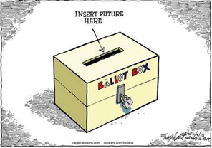  As we reflect on our 95th birthday, it’s a great time to think about the reasons you personally joined the League. What drew you to the League? Were you familiar with League lingo? Did you know everyone at the meeting? We all know that first impressions mean a lot and reflecting on what made us join and stay with the League can help us ensure we are creating those warm and welcoming conditions for new members today.  The future of the League and our democracy depends on a vibrant membership. Let’s start our next 95 years off with a strong and energized League! Here are some of the quick tips that the MLD program helps League implement at every new event to ensure that the communities we engage with feel welcome to join us:  - Ask new members to volunteer at the next League event. What is a small task that you might ask them to assist with? Welcome people? Help set up the room? Collect questions from the audience? After the event, what they thought and what would interest them about the next event?  - Call them to action: Ask them to take some kind of action. Take a friend to vote! Become a fan of the League’s Facebook page! Follow us on Twitter! Send us a donation!  - Connect them with a League “buddy” or mentor: Recruit League members who will stay in touch with them for the upcoming months. This gives them a contact and someone to ask questions, go to meetings with and generally provide a friendly welcome to the League. Thank them: Everyone appreciates being thanked. Acknowledge their time and effort in participating in the event they attended.  Success Story: Laramie, WY Embraces the GROW ME Coaching Model  In the Membership and Leadership Development (MLD) program, the GROW ME method helps Leagues outline specific goals, assess what the current reality looks like, decide what their options are and finally to choose which option will make their goal a reality.  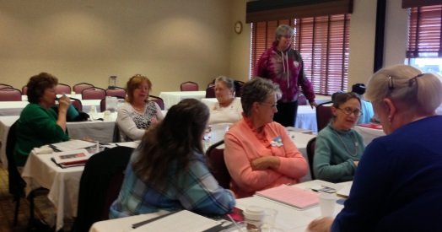  Members of the League of Women Voters of Laramie, Wyoming are successfully integrating the GROW ME model of goal setting and evaluating into every aspect of their work. State MLD coach Susan Simpson says that the model “provides a great framework to help remember goals, recognize their current status, and evaluate how best to proceed,” which the Laramie League has put to good use, setting goals of improving communication by using outlets like Facebook more frequently and doing more follow through with new and potential members. The League is also using the event planning checklist and sign-in sheets at meetings as well as maintaining a mailing list.  Donna Lauffer, Ruth S. Shur Fellow for Wyoming, said “Laramie is well connected with their local newspaper and they do very community-minded programs that attract a diverse grouping of people”, citing the Laramie League’s 30% membership increase from 2013 – 2014. Susan added that “Our MLD team all went through the training together in Casper, so we started out together.”  The GROW ME model is not meant to add to the work load of local Leagues but rather to make it easier for Leagues and their members to get things done through a simple framework that guide Leagues during the planning process and makes that process simpler. The success of the Laramie League with their implementation of the GROW ME model shows how useful and simple the model can be and sets an example for other Leagues to follow.  Looking For a New Way to Get Involved? Become a State Coach!  Are you interested in deepening your League experience and becoming a strong leader at the state level? State coaches are the backbone of the MLD Program and critical to the success of the League. If you are interested in this fulfilling and exciting opportunity please contact your state MLD representative.

